## ****Use Case Document: Banking Application – Loan Recommendation****

### ****Domain****:

Banking and Financial Services

### ****Use Case Name****:

Manage Banking Transactions and Loan Recommendations

### ****Use Case Description****:

### This use case outlines how **users** interact with the banking application for core services like deposits, withdrawals, and viewing loan recommendations, while **bank admins** manage transaction oversight, approve large or suspicious transactions, and configure loan criteria.

### ****Use Case Goal****:

To enable users to perform essential banking transactions (deposit, withdrawal), view transaction history, and receive loan recommendations based on transaction patterns, account activity, and credit rating (CR).Enable **bank admins** to monitor transactions, approve flagged activities, manage user accounts, and update loan rules/criteria.The system should provide real-time updates, secure processing, and a responsive UI.

### ****Actors****:

* **Customer**
* **Bank Admin**
* **Loan Recommendation Engine**
* **Credit Rating API (3rd Party)**

### ****Pre-Conditions****:

* Customer is registered and logged into the system.
* Bank admin is authenticated with admin rights.
* Active bank account is linked.
* Valid credit rating exists (or fetched via API).
* Bank servers are online and accessible.

### ****Post-Conditions****:

* Deposits/Withdrawals are recorded in the transaction history.
* Account balance is updated.
* Notifications are sent for each transaction.
* Loan recommendations are generated and shown.
* Credit rating is updated periodically.
* Admin actions(approval, modifications) logged.

## ****Main Flow (Basic Path)****

****User Side:****

1. **Login & Dashboard Access**

* User logs into the app and views their account dashboard.

1. **Deposit Funds**

* User selects the deposit option, enters the amount and mode (Bank transfer, UPI, cheque)
* System confirms deposit and updates balance.

1. **Withdraw Funds**

* User chooses withdrawal, enters the amount.
* If sufficient balance, amount is debited and balance updated.

1. **Transaction Logging**

* All deposits and withdrawals are logged and visible in transaction history.

1. **Loan Recommendation Process**

* The system periodically evaluates the user’s transaction patterns and credit rating.
* If eligible, loan options are shown with type, limit, tenure, and interest rates.
* User can click “Know More” or “Apply Now.”

1. **Notifications & History**

* Push/email notifications sent after transactions.
* Loan recommendation history stored.

**Bank admin side:**

**1 **Login & Admin Dashboard****

* Admin logs in to admin portal

**2 **Monitor Transactions:****

* View all transaction logs
* Approve/decline flagged, large, or suspicious transactions

**3 Manage Users**

* View, update or deactivate customer accounts

**4 Loan Policy Management**

* Configure recommendation rules (e.g. credit score thresholds, income levels, max loan limits)
* Approve/decline loan applications

**5 View Reports**

* View transaction summaries, user activity, and loan approvals

## ****Alternative Flows****

* **Insufficient Funds**:  
  Show "Insufficient Balance" warning and abort withdrawal.
* **Invalid Credit Rating**:  
  If CR API fails, show fallback: "Loan Recommendation not available at the moment."
* **Suspicious transaction( Admin):**Flag transaction for review
* **Loan Already Active**:  
  If a loan is already in progress, system doesn’t show new recommendation or allow if income & CR permit second loan .
* **Multiple Loan Types Requested:** Recommend both if eligible or ask user to choose one if not eligible for both
* **No Transactions Yet (User Just Signed Up):** Show prompt: "Start using your account to get personalized loan options."

## ****Exception Handling****

* **API Timeout (CR or Transaction API)**:  
  Retry mechanism or notify user.
* **Unauthorized Access**:  
  Redirect to login if session expires.
* **Double Submission Prevention**:  
  Use request locking to prevent double deposits/withdrawals.

## ****Possible Test Cases****

| **Test Case ID** | **Description** | **Input Data** | **Expected Outcome** |
| --- | --- | --- | --- |
| TC001 | Register new customer | Name, Email, Password | User account created |
| TC002 | Login valid user | Email, password | Login successful |
| TC003 | Deposit funds | Valid amount | Balance updated, success message |
| TC004 | Withdraw funds (sufficient balance) | Valid amount | Withdrawal complete |
| TC005 | Withdraw funds (low balance) | Amount > balance | Error: Insufficient funds |
| TC006 | View transactions | Account ID | Show full transaction history |
| TC007 | API failure during loan recommendation | N/A | Show fallback message |
| TC008 | Valid transaction history triggers loan suggestion | Pattern detected | Show eligible loan details |
| TC009 | Logout | Click logout | User logged out |
| TC010 | View loan recommendation | Logged-in user | Personalized loan card shown |
| TC011 | Approve flagged transcation(Admin) | Trasaction id | Approval complete |
| TC012 | View reports | N/A | Report displayed |
| TC013 | Manage users | User details | Updated or blocked |

## ****Expected Outcome****

* Users can securely deposit and withdraw funds.
* A loan suggestion is generated automatically based on real-time transactional behavior and credit rating.
* Responsive UI with modern UX allows seamless interaction.
* APIs ensure real-time processing and smart decision-making.

## ****Sequence diagram****

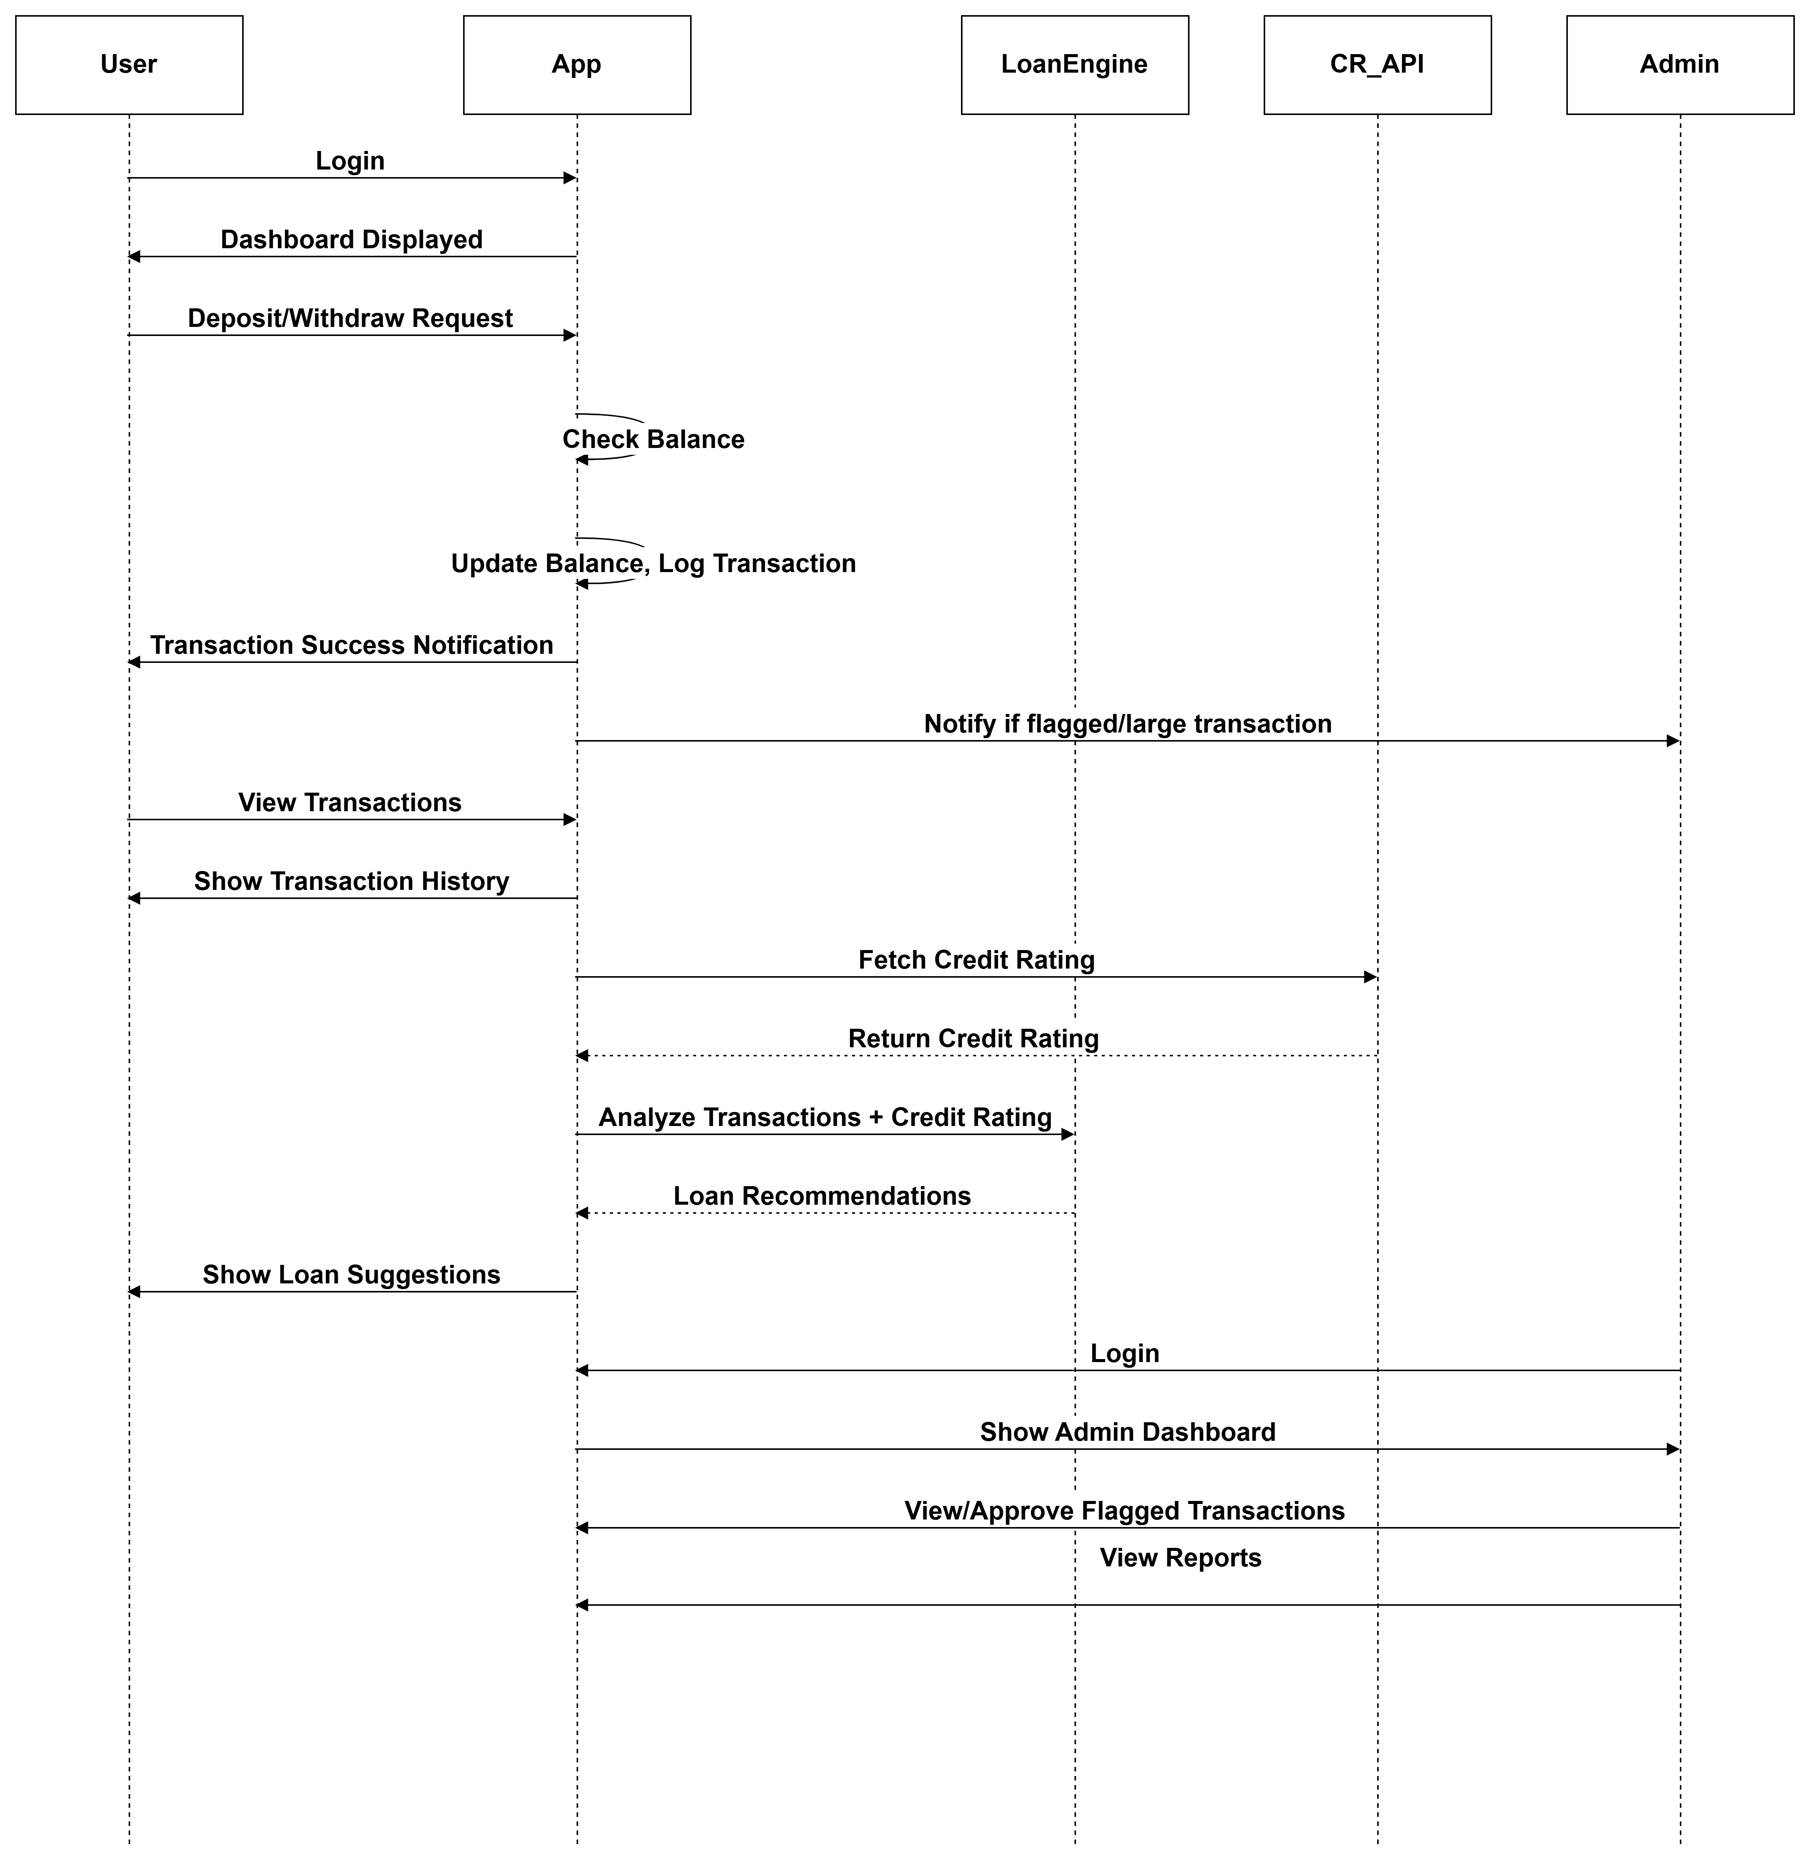

****Workflow diagram****

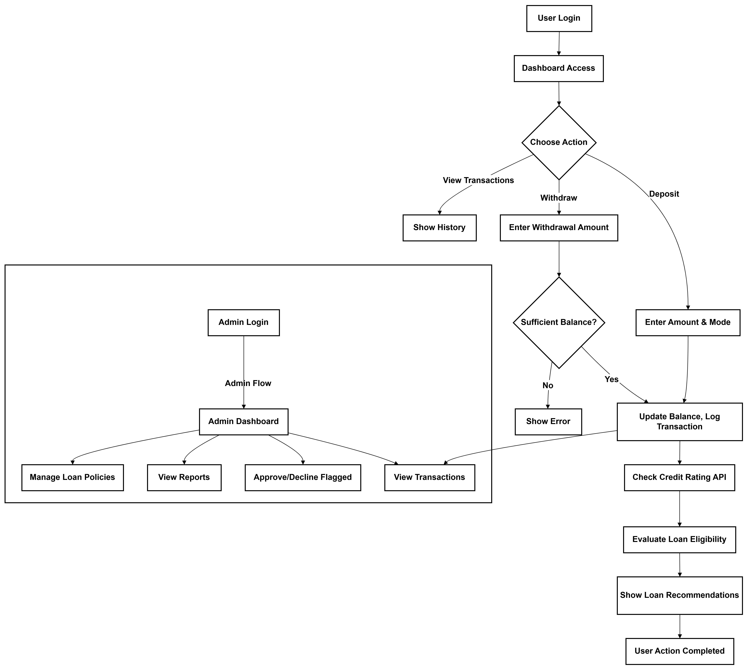

## ****Database diagram****

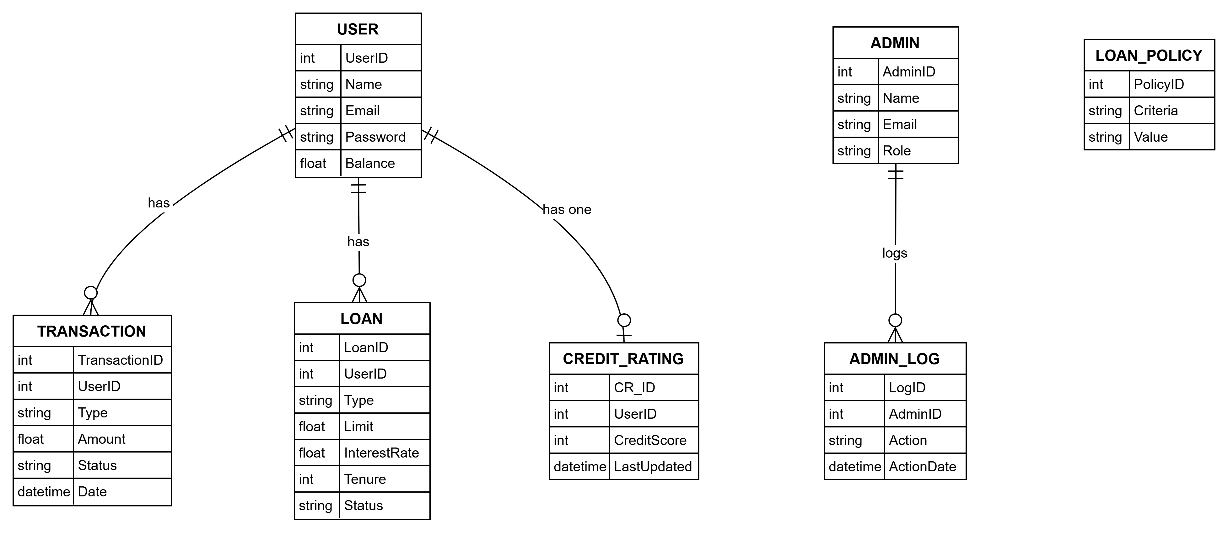

## ****Functional architecture diagram****

%3CmxGraphModel%3E%3Croot%3E%3CmxCell%20id%3D%220%22%2F%3E%3CmxCell%20id%3D%221%22%20parent%3D%220%22%2F%3E%3CmxCell%20id%3D%222%22%20value%3D%22User%20Side%22%20style%3D%22whiteSpace%3Dwrap%3BstrokeWidth%3D2%3B%22%20vertex%3D%221%22%20parent%3D%221%22%3E%3CmxGeometry%20x%3D%2220%22%20y%3D%2290%22%20width%3D%22292%22%20height%3D%22494%22%20as%3D%22geometry%22%2F%3E%3C%2FmxCell%3E%3CmxCell%20id%3D%223%22%20value%3D%22Login%20%26amp%3B%20Dashboard%22%20style%3D%22whiteSpace%3Dwrap%3BstrokeWidth%3D2%3B%22%20vertex%3D%221%22%20parent%3D%221%22%3E%3CmxGeometry%20x%3D%2268.5%22%20y%3D%22150%22%20width%3D%22193%22%20height%3D%2254%22%20as%3D%22geometry%22%2F%3E%3C%2FmxCell%3E%3CmxCell%20id%3D%224%22%20value%3D%22Deposit%20%2F%20Withdraw%22%20style%3D%22whiteSpace%3Dwrap%3BstrokeWidth%3D2%3B%22%20vertex%3D%221%22%20parent%3D%221%22%3E%3CmxGeometry%20x%3D%2265.5%22%20y%3D%22254%22%20width%3D%22200%22%20height%3D%2254%22%20as%3D%22geometry%22%2F%3E%3C%2FmxCell%3E%3CmxCell%20id%3D%225%22%20value%3D%22Transaction%20History%22%20style%3D%22whiteSpace%3Dwrap%3BstrokeWidth%3D2%3B%22%20vertex%3D%221%22%20parent%3D%221%22%3E%3CmxGeometry%20x%3D%2267.5%22%20y%3D%22358%22%20width%3D%22197%22%20height%3D%2254%22%20as%3D%22geometry%22%2F%3E%3C%2FmxCell%3E%3CmxCell%20id%3D%226%22%20value%3D%22Loan%20Recommendations%22%20style%3D%22whiteSpace%3Dwrap%3BstrokeWidth%3D2%3B%22%20vertex%3D%221%22%20parent%3D%221%22%3E%3CmxGeometry%20x%3D%2251.5%22%20y%3D%22514%22%20width%3D%22229%22%20height%3D%2254%22%20as%3D%22geometry%22%2F%3E%3C%2FmxCell%3E%3CmxCell%20id%3D%227%22%20value%3D%22Admin%20Side%22%20style%3D%22whiteSpace%3Dwrap%3BstrokeWidth%3D2%3B%22%20vertex%3D%221%22%20parent%3D%221%22%3E%3CmxGeometry%20x%3D%2220%22%20y%3D%22610%22%20width%3D%22292%22%20height%3D%22540%22%20as%3D%22geometry%22%2F%3E%3C%2FmxCell%3E%3CmxCell%20id%3D%228%22%20value%3D%22Login%20%26amp%3B%20Admin%20Dashboard%22%20style%3D%22whiteSpace%3Dwrap%3BstrokeWidth%3D2%3B%22%20vertex%3D%221%22%20parent%3D%221%22%3E%3CmxGeometry%20x%3D%2245.5%22%20y%3D%22630%22%20width%3D%22242%22%20height%3D%2254%22%20as%3D%22geometry%22%2F%3E%3C%2FmxCell%3E%3CmxCell%20id%3D%229%22%20value%3D%22Manage%20Transactions%22%20style%3D%22whiteSpace%3Dwrap%3BstrokeWidth%3D2%3B%22%20vertex%3D%221%22%20parent%3D%221%22%3E%3CmxGeometry%20x%3D%2261.5%22%20y%3D%22710%22%20width%3D%22207%22%20height%3D%2254%22%20as%3D%22geometry%22%2F%3E%3C%2FmxCell%3E%3CmxCell%20id%3D%2210%22%20value%3D%22Approve%20Loans%22%20style%3D%22whiteSpace%3Dwrap%3BstrokeWidth%3D2%3B%22%20vertex%3D%221%22%20parent%3D%221%22%3E%3CmxGeometry%20x%3D%2279%22%20y%3D%22790%22%20width%3D%22164%22%20height%3D%2254%22%20as%3D%22geometry%22%2F%3E%3C%2FmxCell%3E%3CmxCell%20id%3D%2211%22%20value%3D%22View%20Reports%22%20style%3D%22whiteSpace%3Dwrap%3BstrokeWidth%3D2%3B%22%20vertex%3D%221%22%20parent%3D%221%22%3E%3CmxGeometry%20x%3D%2288.5%22%20y%3D%22940%22%20width%3D%22153%22%20height%3D%2254%22%20as%3D%22geometry%22%2F%3E%3C%2FmxCell%3E%3CmxCell%20id%3D%2212%22%20value%3D%22Configure%20Loan%20Policies%22%20style%3D%22whiteSpace%3Dwrap%3BstrokeWidth%3D2%3B%22%20vertex%3D%221%22%20parent%3D%221%22%3E%3CmxGeometry%20x%3D%2261.5%22%20y%3D%221040%22%20width%3D%22226%22%20height%3D%2254%22%20as%3D%22geometry%22%2F%3E%3C%2FmxCell%3E%3CmxCell%20id%3D%2213%22%20value%3D%22Backend%20Services%22%20style%3D%22whiteSpace%3Dwrap%3BstrokeWidth%3D2%3B%22%20vertex%3D%221%22%20parent%3D%221%22%3E%3CmxGeometry%20x%3D%22400%22%20y%3D%2270%22%20width%3D%22572%22%20height%3D%221100%22%20as%3D%22geometry%22%2F%3E%3C%2FmxCell%3E%3CmxCell%20id%3D%2214%22%20value%3D%22Transaction%20Database%22%20style%3D%22whiteSpace%3Dwrap%3BstrokeWidth%3D2%3B%22%20vertex%3D%221%22%20parent%3D%221%22%3E%3CmxGeometry%20x%3D%22419%22%20y%3D%22170%22%20width%3D%22212%22%20height%3D%2254%22%20as%3D%22geometry%22%2F%3E%3C%2FmxCell%3E%3CmxCell%20id%3D%2215%22%20value%3D%22Loan%20Recommendation%20Engine%22%20style%3D%22whiteSpace%3Dwrap%3BstrokeWidth%3D2%3B%22%20vertex%3D%221%22%20parent%3D%221%22%3E%3CmxGeometry%20x%3D%22660%22%20y%3D%22660%22%20width%3D%22260%22%20height%3D%2278%22%20as%3D%22geometry%22%2F%3E%3C%2FmxCell%3E%3CmxCell%20id%3D%2216%22%20value%3D%22Notification%20System%22%20style%3D%22whiteSpace%3Dwrap%3BstrokeWidth%3D2%3B%22%20vertex%3D%221%22%20parent%3D%221%22%3E%3CmxGeometry%20x%3D%22437%22%20y%3D%22280%22%20width%3D%22200%22%20height%3D%2254%22%20as%3D%22geometry%22%2F%3E%3C%2FmxCell%3E%3CmxCell%20id%3D%2217%22%20value%3D%22Loan%20Policy%20Database%22%20style%3D%22whiteSpace%3Dwrap%3BstrokeWidth%3D2%3B%22%20vertex%3D%221%22%20parent%3D%221%22%3E%3CmxGeometry%20x%3D%22425%22%20y%3D%221040%22%20width%3D%22211%22%20height%3D%2254%22%20as%3D%22geometry%22%2F%3E%3C%2FmxCell%3E%3CmxCell%20id%3D%2218%22%20value%3D%22%22%20style%3D%22endArrow%3Dclassic%3Bhtml%3D1%3Brounded%3D0%3BexitX%3D1%3BexitY%3D0.5%3BexitDx%3D0%3BexitDy%3D0%3BentryX%3D0%3BentryY%3D0%3BentryDx%3D0%3BentryDy%3D0%3B%22%20edge%3D%221%22%20source%3D%223%22%20target%3D%2214%22%20parent%3D%221%22%3E%3CmxGeometry%20width%3D%2250%22%20height%3D%2250%22%20relative%3D%221%22%20as%3D%22geometry%22%3E%3CmxPoint%20x%3D%22400%22%20y%3D%22500%22%20as%3D%22sourcePoint%22%2F%3E%3CmxPoint%20x%3D%22450%22%20y%3D%22450%22%20as%3D%22targetPoint%22%2F%3E%3C%2FmxGeometry%3E%3C%2FmxCell%3E%3CmxCell%20id%3D%2219%22%20value%3D%22Credit%20Rating%20API%22%20style%3D%22whiteSpace%3Dwrap%3BstrokeWidth%3D2%3B%22%20vertex%3D%221%22%20parent%3D%221%22%3E%3CmxGeometry%20x%3D%22446.5%22%20y%3D%22514%22%20width%3D%22181%22%20height%3D%2254%22%20as%3D%22geometry%22%2F%3E%3C%2FmxCell%3E%3CmxCell%20id%3D%2220%22%20value%3D%22%22%20style%3D%22endArrow%3Dclassic%3Bhtml%3D1%3Brounded%3D0%3BexitX%3D1%3BexitY%3D0%3BexitDx%3D0%3BexitDy%3D0%3BentryX%3D0%3BentryY%3D0.25%3BentryDx%3D0%3BentryDy%3D0%3B%22%20edge%3D%221%22%20source%3D%224%22%20target%3D%2214%22%20parent%3D%221%22%3E%3CmxGeometry%20width%3D%2250%22%20height%3D%2250%22%20relative%3D%221%22%20as%3D%22geometry%22%3E%3CmxPoint%20x%3D%22272%22%20y%3D%22187%22%20as%3D%22sourcePoint%22%2F%3E%3CmxPoint%20x%3D%22435%22%20y%3D%22298%22%20as%3D%22targetPoint%22%2F%3E%3C%2FmxGeometry%3E%3C%2FmxCell%3E%3CmxCell%20id%3D%2221%22%20value%3D%22%22%20style%3D%22endArrow%3Dclassic%3Bhtml%3D1%3Brounded%3D0%3BexitX%3D1%3BexitY%3D0.5%3BexitDx%3D0%3BexitDy%3D0%3BentryX%3D0%3BentryY%3D0.5%3BentryDx%3D0%3BentryDy%3D0%3B%22%20edge%3D%221%22%20source%3D%225%22%20target%3D%2214%22%20parent%3D%221%22%3E%3CmxGeometry%20width%3D%2250%22%20height%3D%2250%22%20relative%3D%221%22%20as%3D%22geometry%22%3E%3CmxPoint%20x%3D%22282%22%20y%3D%22197%22%20as%3D%22sourcePoint%22%2F%3E%3CmxPoint%20x%3D%22445%22%20y%3D%22308%22%20as%3D%22targetPoint%22%2F%3E%3C%2FmxGeometry%3E%3C%2FmxCell%3E%3CmxCell%20id%3D%2222%22%20value%3D%22%22%20style%3D%22endArrow%3Dclassic%3Bhtml%3D1%3Brounded%3D0%3BexitX%3D1%3BexitY%3D0.5%3BexitDx%3D0%3BexitDy%3D0%3BentryX%3D0%3BentryY%3D0.5%3BentryDx%3D0%3BentryDy%3D0%3B%22%20edge%3D%221%22%20source%3D%224%22%20target%3D%2216%22%20parent%3D%221%22%3E%3CmxGeometry%20width%3D%2250%22%20height%3D%2250%22%20relative%3D%221%22%20as%3D%22geometry%22%3E%3CmxPoint%20x%3D%22292%22%20y%3D%22207%22%20as%3D%22sourcePoint%22%2F%3E%3CmxPoint%20x%3D%22455%22%20y%3D%22318%22%20as%3D%22targetPoint%22%2F%3E%3C%2FmxGeometry%3E%3C%2FmxCell%3E%3CmxCell%20id%3D%2223%22%20value%3D%22%22%20style%3D%22endArrow%3Dclassic%3Bhtml%3D1%3Brounded%3D0%3BexitX%3D1%3BexitY%3D0.5%3BexitDx%3D0%3BexitDy%3D0%3BentryX%3D0%3BentryY%3D0.5%3BentryDx%3D0%3BentryDy%3D0%3B%22%20edge%3D%221%22%20source%3D%226%22%20target%3D%2219%22%20parent%3D%221%22%3E%3CmxGeometry%20width%3D%2250%22%20height%3D%2250%22%20relative%3D%221%22%20as%3D%22geometry%22%3E%3CmxPoint%20x%3D%22302%22%20y%3D%22217%22%20as%3D%22sourcePoint%22%2F%3E%3CmxPoint%20x%3D%22465%22%20y%3D%22328%22%20as%3D%22targetPoint%22%2F%3E%3C%2FmxGeometry%3E%3C%2FmxCell%3E%3CmxCell%20id%3D%2224%22%20value%3D%22%22%20style%3D%22endArrow%3Dclassic%3Bhtml%3D1%3Brounded%3D0%3BexitX%3D1%3BexitY%3D1%3BexitDx%3D0%3BexitDy%3D0%3BentryX%3D0.25%3BentryY%3D0%3BentryDx%3D0%3BentryDy%3D0%3B%22%20edge%3D%221%22%20source%3D%2219%22%20target%3D%2215%22%20parent%3D%221%22%3E%3CmxGeometry%20width%3D%2250%22%20height%3D%2250%22%20relative%3D%221%22%20as%3D%22geometry%22%3E%3CmxPoint%20x%3D%22312%22%20y%3D%22227%22%20as%3D%22sourcePoint%22%2F%3E%3CmxPoint%20x%3D%22475%22%20y%3D%22338%22%20as%3D%22targetPoint%22%2F%3E%3C%2FmxGeometry%3E%3C%2FmxCell%3E%3CmxCell%20id%3D%2225%22%20value%3D%22%22%20style%3D%22endArrow%3Dclassic%3Bhtml%3D1%3Brounded%3D0%3BexitX%3D1%3BexitY%3D0.5%3BexitDx%3D0%3BexitDy%3D0%3BentryX%3D0%3BentryY%3D0.5%3BentryDx%3D0%3BentryDy%3D0%3B%22%20edge%3D%221%22%20source%3D%2212%22%20target%3D%2217%22%20parent%3D%221%22%3E%3CmxGeometry%20width%3D%2250%22%20height%3D%2250%22%20relative%3D%221%22%20as%3D%22geometry%22%3E%3CmxPoint%20x%3D%22340%22%20y%3D%22940%22%20as%3D%22sourcePoint%22%2F%3E%3CmxPoint%20x%3D%22485%22%20y%3D%22348%22%20as%3D%22targetPoint%22%2F%3E%3C%2FmxGeometry%3E%3C%2FmxCell%3E%3CmxCell%20id%3D%2226%22%20value%3D%22Transaction%20Database%22%20style%3D%22whiteSpace%3Dwrap%3BstrokeWidth%3D2%3B%22%20vertex%3D%221%22%20parent%3D%221%22%3E%3CmxGeometry%20x%3D%22424%22%20y%3D%22684%22%20width%3D%22212%22%20height%3D%2254%22%20as%3D%22geometry%22%2F%3E%3C%2FmxCell%3E%3CmxCell%20id%3D%2227%22%20value%3D%22%22%20style%3D%22endArrow%3Dclassic%3Bhtml%3D1%3Brounded%3D0%3B%22%20edge%3D%221%22%20source%3D%2210%22%20target%3D%2217%22%20parent%3D%221%22%3E%3CmxGeometry%20width%3D%2250%22%20height%3D%2250%22%20relative%3D%221%22%20as%3D%22geometry%22%3E%3CmxPoint%20x%3D%22370%22%20y%3D%22830%22%20as%3D%22sourcePoint%22%2F%3E%3CmxPoint%20x%3D%22420%22%20y%3D%22780%22%20as%3D%22targetPoint%22%2F%3E%3C%2FmxGeometry%3E%3C%2FmxCell%3E%3CmxCell%20id%3D%2228%22%20value%3D%22%22%20style%3D%22endArrow%3Dclassic%3Bhtml%3D1%3Brounded%3D0%3BexitX%3D1%3BexitY%3D0.75%3BexitDx%3D0%3BexitDy%3D0%3BentryX%3D0.339%3BentryY%3D0.991%3BentryDx%3D0%3BentryDy%3D0%3BentryPerimeter%3D0%3B%22%20edge%3D%221%22%20source%3D%2210%22%20target%3D%2215%22%20parent%3D%221%22%3E%3CmxGeometry%20width%3D%2250%22%20height%3D%2250%22%20relative%3D%221%22%20as%3D%22geometry%22%3E%3CmxPoint%20x%3D%22211%22%20y%3D%22854%22%20as%3D%22sourcePoint%22%2F%3E%3CmxPoint%20x%3D%22501%22%20y%3D%221050%22%20as%3D%22targetPoint%22%2F%3E%3C%2FmxGeometry%3E%3C%2FmxCell%3E%3CmxCell%20id%3D%2229%22%20value%3D%22%22%20style%3D%22endArrow%3Dclassic%3Bhtml%3D1%3Brounded%3D0%3BexitX%3D0%3BexitY%3D0%3BexitDx%3D0%3BexitDy%3D0%3BentryX%3D1%3BentryY%3D1%3BentryDx%3D0%3BentryDy%3D0%3B%22%20edge%3D%221%22%20source%3D%2215%22%20target%3D%226%22%20parent%3D%221%22%3E%3CmxGeometry%20width%3D%2250%22%20height%3D%2250%22%20relative%3D%221%22%20as%3D%22geometry%22%3E%3CmxPoint%20x%3D%22330%22%20y%3D%22730%22%20as%3D%22sourcePoint%22%2F%3E%3CmxPoint%20x%3D%22380%22%20y%3D%22680%22%20as%3D%22targetPoint%22%2F%3E%3C%2FmxGeometry%3E%3C%2FmxCell%3E%3CmxCell%20id%3D%2230%22%20value%3D%22Notification%20System%22%20style%3D%22whiteSpace%3Dwrap%3BstrokeWidth%3D2%3B%22%20vertex%3D%221%22%20parent%3D%221%22%3E%3CmxGeometry%20x%3D%22437%22%20y%3D%22853%22%20width%3D%22200%22%20height%3D%2254%22%20as%3D%22geometry%22%2F%3E%3C%2FmxCell%3E%3CmxCell%20id%3D%2231%22%20value%3D%22%22%20style%3D%22endArrow%3Dclassic%3Bhtml%3D1%3Brounded%3D0%3BexitX%3D1%3BexitY%3D0.5%3BexitDx%3D0%3BexitDy%3D0%3BentryX%3D0%3BentryY%3D0.5%3BentryDx%3D0%3BentryDy%3D0%3B%22%20edge%3D%221%22%20source%3D%2211%22%20target%3D%2230%22%20parent%3D%221%22%3E%3CmxGeometry%20width%3D%2250%22%20height%3D%2250%22%20relative%3D%221%22%20as%3D%22geometry%22%3E%3CmxPoint%20x%3D%22330%22%20y%3D%22730%22%20as%3D%22sourcePoint%22%2F%3E%3CmxPoint%20x%3D%22380%22%20y%3D%22680%22%20as%3D%22targetPoint%22%2F%3E%3C%2FmxGeometry%3E%3C%2FmxCell%3E%3CmxCell%20id%3D%2232%22%20value%3D%22%22%20style%3D%22endArrow%3Dclassic%3Bhtml%3D1%3Brounded%3D0%3BexitX%3D1%3BexitY%3D0.5%3BexitDx%3D0%3BexitDy%3D0%3BentryX%3D0%3BentryY%3D0.5%3BentryDx%3D0%3BentryDy%3D0%3B%22%20edge%3D%221%22%20source%3D%229%22%20target%3D%2226%22%20parent%3D%221%22%3E%3CmxGeometry%20width%3D%2250%22%20height%3D%2250%22%20relative%3D%221%22%20as%3D%22geometry%22%3E%3CmxPoint%20x%3D%22330%22%20y%3D%22730%22%20as%3D%22sourcePoint%22%2F%3E%3CmxPoint%20x%3D%22380%22%20y%3D%22680%22%20as%3D%22targetPoint%22%2F%3E%3C%2FmxGeometry%3E%3C%2FmxCell%3E%3CmxCell%20id%3D%2233%22%20value%3D%22%22%20style%3D%22endArrow%3Dclassic%3Bhtml%3D1%3Brounded%3D0%3BexitX%3D1%3BexitY%3D0.75%3BexitDx%3D0%3BexitDy%3D0%3BentryX%3D0%3BentryY%3D0.5%3BentryDx%3D0%3BentryDy%3D0%3B%22%20edge%3D%221%22%20source%3D%229%22%20target%3D%2230%22%20parent%3D%221%22%3E%3CmxGeometry%20width%3D%2250%22%20height%3D%2250%22%20relative%3D%221%22%20as%3D%22geometry%22%3E%3CmxPoint%20x%3D%22330%22%20y%3D%22730%22%20as%3D%22sourcePoint%22%2F%3E%3CmxPoint%20x%3D%22380%22%20y%3D%22680%22%20as%3D%22targetPoint%22%2F%3E%3C%2FmxGeometry%3E%3C%2FmxCell%3E%3CmxCell%20id%3D%2234%22%20value%3D%22%22%20style%3D%22endArrow%3Dclassic%3Bhtml%3D1%3Brounded%3D0%3BexitX%3D1%3BexitY%3D0.75%3BexitDx%3D0%3BexitDy%3D0%3BentryX%3D0%3BentryY%3D0.25%3BentryDx%3D0%3BentryDy%3D0%3B%22%20edge%3D%221%22%20source%3D%228%22%20target%3D%2226%22%20parent%3D%221%22%3E%3CmxGeometry%20width%3D%2250%22%20height%3D%2250%22%20relative%3D%221%22%20as%3D%22geometry%22%3E%3CmxPoint%20x%3D%22330%22%20y%3D%22730%22%20as%3D%22sourcePoint%22%2F%3E%3CmxPoint%20x%3D%22380%22%20y%3D%22680%22%20as%3D%22targetPoint%22%2F%3E%3C%2FmxGeometry%3E%3C%2FmxCell%3E%3C%2Froot%3E%3C%2FmxGraphModel%3E

%3CmxGraphModel%3E%3Croot%3E%3CmxCell%20id%3D%220%22%2F%3E%3CmxCell%20id%3D%221%22%20parent%3D%220%22%2F%3E%3CmxCell%20id%3D%222%22%20value%3D%22User%20Side%22%20style%3D%22whiteSpace%3Dwrap%3BstrokeWidth%3D2%3B%22%20vertex%3D%221%22%20parent%3D%221%22%3E%3CmxGeometry%20x%3D%2220%22%20y%3D%2290%22%20width%3D%22292%22%20height%3D%22494%22%20as%3D%22geometry%22%2F%3E%3C%2FmxCell%3E%3CmxCell%20id%3D%223%22%20value%3D%22Login%20%26amp%3B%20Dashboard%22%20style%3D%22whiteSpace%3Dwrap%3BstrokeWidth%3D2%3B%22%20vertex%3D%221%22%20parent%3D%221%22%3E%3CmxGeometry%20x%3D%2268.5%22%20y%3D%22150%22%20width%3D%22193%22%20height%3D%2254%22%20as%3D%22geometry%22%2F%3E%3C%2FmxCell%3E%3CmxCell%20id%3D%224%22%20value%3D%22Deposit%20%2F%20Withdraw%22%20style%3D%22whiteSpace%3Dwrap%3BstrokeWidth%3D2%3B%22%20vertex%3D%221%22%20parent%3D%221%22%3E%3CmxGeometry%20x%3D%2265.5%22%20y%3D%22254%22%20width%3D%22200%22%20height%3D%2254%22%20as%3D%22geometry%22%2F%3E%3C%2FmxCell%3E%3CmxCell%20id%3D%225%22%20value%3D%22Transaction%20History%22%20style%3D%22whiteSpace%3Dwrap%3BstrokeWidth%3D2%3B%22%20vertex%3D%221%22%20parent%3D%221%22%3E%3CmxGeometry%20x%3D%2267.5%22%20y%3D%22358%22%20width%3D%22197%22%20height%3D%2254%22%20as%3D%22geometry%22%2F%3E%3C%2FmxCell%3E%3CmxCell%20id%3D%226%22%20value%3D%22Loan%20Recommendations%22%20style%3D%22whiteSpace%3Dwrap%3BstrokeWidth%3D2%3B%22%20vertex%3D%221%22%20parent%3D%221%22%3E%3CmxGeometry%20x%3D%2251.5%22%20y%3D%22514%22%20width%3D%22229%22%20height%3D%2254%22%20as%3D%22geometry%22%2F%3E%3C%2FmxCell%3E%3CmxCell%20id%3D%227%22%20value%3D%22Admin%20Side%22%20style%3D%22whiteSpace%3Dwrap%3BstrokeWidth%3D2%3B%22%20vertex%3D%221%22%20parent%3D%221%22%3E%3CmxGeometry%20x%3D%2220%22%20y%3D%22610%22%20width%3D%22292%22%20height%3D%22540%22%20as%3D%22geometry%22%2F%3E%3C%2FmxCell%3E%3CmxCell%20id%3D%228%22%20value%3D%22Login%20%26amp%3B%20Admin%20Dashboard%22%20style%3D%22whiteSpace%3Dwrap%3BstrokeWidth%3D2%3B%22%20vertex%3D%221%22%20parent%3D%221%22%3E%3CmxGeometry%20x%3D%2245.5%22%20y%3D%22630%22%20width%3D%22242%22%20height%3D%2254%22%20as%3D%22geometry%22%2F%3E%3C%2FmxCell%3E%3CmxCell%20id%3D%229%22%20value%3D%22Manage%20Transactions%22%20style%3D%22whiteSpace%3Dwrap%3BstrokeWidth%3D2%3B%22%20vertex%3D%221%22%20parent%3D%221%22%3E%3CmxGeometry%20x%3D%2261.5%22%20y%3D%22710%22%20width%3D%22207%22%20height%3D%2254%22%20as%3D%22geometry%22%2F%3E%3C%2FmxCell%3E%3CmxCell%20id%3D%2210%22%20value%3D%22Approve%20Loans%22%20style%3D%22whiteSpace%3Dwrap%3BstrokeWidth%3D2%3B%22%20vertex%3D%221%22%20parent%3D%221%22%3E%3CmxGeometry%20x%3D%2279%22%20y%3D%22790%22%20width%3D%22164%22%20height%3D%2254%22%20as%3D%22geometry%22%2F%3E%3C%2FmxCell%3E%3CmxCell%20id%3D%2211%22%20value%3D%22View%20Reports%22%20style%3D%22whiteSpace%3Dwrap%3BstrokeWidth%3D2%3B%22%20vertex%3D%221%22%20parent%3D%221%22%3E%3CmxGeometry%20x%3D%2288.5%22%20y%3D%22940%22%20width%3D%22153%22%20height%3D%2254%22%20as%3D%22geometry%22%2F%3E%3C%2FmxCell%3E%3CmxCell%20id%3D%2212%22%20value%3D%22Configure%20Loan%20Policies%22%20style%3D%22whiteSpace%3Dwrap%3BstrokeWidth%3D2%3B%22%20vertex%3D%221%22%20parent%3D%221%22%3E%3CmxGeometry%20x%3D%2261.5%22%20y%3D%221040%22%20width%3D%22226%22%20height%3D%2254%22%20as%3D%22geometry%22%2F%3E%3C%2FmxCell%3E%3CmxCell%20id%3D%2213%22%20value%3D%22Backend%20Services%22%20style%3D%22whiteSpace%3Dwrap%3BstrokeWidth%3D2%3B%22%20vertex%3D%221%22%20parent%3D%221%22%3E%3CmxGeometry%20x%3D%22400%22%20y%3D%2270%22%20width%3D%22572%22%20height%3D%221100%22%20as%3D%22geometry%22%2F%3E%3C%2FmxCell%3E%3CmxCell%20id%3D%2214%22%20value%3D%22Transaction%20Database%22%20style%3D%22whiteSpace%3Dwrap%3BstrokeWidth%3D2%3B%22%20vertex%3D%221%22%20parent%3D%221%22%3E%3CmxGeometry%20x%3D%22419%22%20y%3D%22170%22%20width%3D%22212%22%20height%3D%2254%22%20as%3D%22geometry%22%2F%3E%3C%2FmxCell%3E%3CmxCell%20id%3D%2215%22%20value%3D%22Loan%20Recommendation%20Engine%22%20style%3D%22whiteSpace%3Dwrap%3BstrokeWidth%3D2%3B%22%20vertex%3D%221%22%20parent%3D%221%22%3E%3CmxGeometry%20x%3D%22660%22%20y%3D%22660%22%20width%3D%22260%22%20height%3D%2278%22%20as%3D%22geometry%22%2F%3E%3C%2FmxCell%3E%3CmxCell%20id%3D%2216%22%20value%3D%22Notification%20System%22%20style%3D%22whiteSpace%3Dwrap%3BstrokeWidth%3D2%3B%22%20vertex%3D%221%22%20parent%3D%221%22%3E%3CmxGeometry%20x%3D%22437%22%20y%3D%22280%22%20width%3D%22200%22%20height%3D%2254%22%20as%3D%22geometry%22%2F%3E%3C%2FmxCell%3E%3CmxCell%20id%3D%2217%22%20value%3D%22Loan%20Policy%20Database%22%20style%3D%22whiteSpace%3Dwrap%3BstrokeWidth%3D2%3B%22%20vertex%3D%221%22%20parent%3D%221%22%3E%3CmxGeometry%20x%3D%22425%22%20y%3D%221040%22%20width%3D%22211%22%20height%3D%2254%22%20as%3D%22geometry%22%2F%3E%3C%2FmxCell%3E%3CmxCell%20id%3D%2218%22%20value%3D%22%22%20style%3D%22endArrow%3Dclassic%3Bhtml%3D1%3Brounded%3D0%3BexitX%3D1%3BexitY%3D0.5%3BexitDx%3D0%3BexitDy%3D0%3BentryX%3D0%3BentryY%3D0%3BentryDx%3D0%3BentryDy%3D0%3B%22%20edge%3D%221%22%20source%3D%223%22%20target%3D%2214%22%20parent%3D%221%22%3E%3CmxGeometry%20width%3D%2250%22%20height%3D%2250%22%20relative%3D%221%22%20as%3D%22geometry%22%3E%3CmxPoint%20x%3D%22400%22%20y%3D%22500%22%20as%3D%22sourcePoint%22%2F%3E%3CmxPoint%20x%3D%22450%22%20y%3D%22450%22%20as%3D%22targetPoint%22%2F%3E%3C%2FmxGeometry%3E%3C%2FmxCell%3E%3CmxCell%20id%3D%2219%22%20value%3D%22Credit%20Rating%20API%22%20style%3D%22whiteSpace%3Dwrap%3BstrokeWidth%3D2%3B%22%20vertex%3D%221%22%20parent%3D%221%22%3E%3CmxGeometry%20x%3D%22446.5%22%20y%3D%22514%22%20width%3D%22181%22%20height%3D%2254%22%20as%3D%22geometry%22%2F%3E%3C%2FmxCell%3E%3CmxCell%20id%3D%2220%22%20value%3D%22%22%20style%3D%22endArrow%3Dclassic%3Bhtml%3D1%3Brounded%3D0%3BexitX%3D1%3BexitY%3D0%3BexitDx%3D0%3BexitDy%3D0%3BentryX%3D0%3BentryY%3D0.25%3BentryDx%3D0%3BentryDy%3D0%3B%22%20edge%3D%221%22%20source%3D%224%22%20target%3D%2214%22%20parent%3D%221%22%3E%3CmxGeometry%20width%3D%2250%22%20height%3D%2250%22%20relative%3D%221%22%20as%3D%22geometry%22%3E%3CmxPoint%20x%3D%22272%22%20y%3D%22187%22%20as%3D%22sourcePoint%22%2F%3E%3CmxPoint%20x%3D%22435%22%20y%3D%22298%22%20as%3D%22targetPoint%22%2F%3E%3C%2FmxGeometry%3E%3C%2FmxCell%3E%3CmxCell%20id%3D%2221%22%20value%3D%22%22%20style%3D%22endArrow%3Dclassic%3Bhtml%3D1%3Brounded%3D0%3BexitX%3D1%3BexitY%3D0.5%3BexitDx%3D0%3BexitDy%3D0%3BentryX%3D0%3BentryY%3D0.5%3BentryDx%3D0%3BentryDy%3D0%3B%22%20edge%3D%221%22%20source%3D%225%22%20target%3D%2214%22%20parent%3D%221%22%3E%3CmxGeometry%20width%3D%2250%22%20height%3D%2250%22%20relative%3D%221%22%20as%3D%22geometry%22%3E%3CmxPoint%20x%3D%22282%22%20y%3D%22197%22%20as%3D%22sourcePoint%22%2F%3E%3CmxPoint%20x%3D%22445%22%20y%3D%22308%22%20as%3D%22targetPoint%22%2F%3E%3C%2FmxGeometry%3E%3C%2FmxCell%3E%3CmxCell%20id%3D%2222%22%20value%3D%22%22%20style%3D%22endArrow%3Dclassic%3Bhtml%3D1%3Brounded%3D0%3BexitX%3D1%3BexitY%3D0.5%3BexitDx%3D0%3BexitDy%3D0%3BentryX%3D0%3BentryY%3D0.5%3BentryDx%3D0%3BentryDy%3D0%3B%22%20edge%3D%221%22%20source%3D%224%22%20target%3D%2216%22%20parent%3D%221%22%3E%3CmxGeometry%20width%3D%2250%22%20height%3D%2250%22%20relative%3D%221%22%20as%3D%22geometry%22%3E%3CmxPoint%20x%3D%22292%22%20y%3D%22207%22%20as%3D%22sourcePoint%22%2F%3E%3CmxPoint%20x%3D%22455%22%20y%3D%22318%22%20as%3D%22targetPoint%22%2F%3E%3C%2FmxGeometry%3E%3C%2FmxCell%3E%3CmxCell%20id%3D%2223%22%20value%3D%22%22%20style%3D%22endArrow%3Dclassic%3Bhtml%3D1%3Brounded%3D0%3BexitX%3D1%3BexitY%3D0.5%3BexitDx%3D0%3BexitDy%3D0%3BentryX%3D0%3BentryY%3D0.5%3BentryDx%3D0%3BentryDy%3D0%3B%22%20edge%3D%221%22%20source%3D%226%22%20target%3D%2219%22%20parent%3D%221%22%3E%3CmxGeometry%20width%3D%2250%22%20height%3D%2250%22%20relative%3D%221%22%20as%3D%22geometry%22%3E%3CmxPoint%20x%3D%22302%22%20y%3D%22217%22%20as%3D%22sourcePoint%22%2F%3E%3CmxPoint%20x%3D%22465%22%20y%3D%22328%22%20as%3D%22targetPoint%22%2F%3E%3C%2FmxGeometry%3E%3C%2FmxCell%3E%3CmxCell%20id%3D%2224%22%20value%3D%22%22%20style%3D%22endArrow%3Dclassic%3Bhtml%3D1%3Brounded%3D0%3BexitX%3D1%3BexitY%3D1%3BexitDx%3D0%3BexitDy%3D0%3BentryX%3D0.25%3BentryY%3D0%3BentryDx%3D0%3BentryDy%3D0%3B%22%20edge%3D%221%22%20source%3D%2219%22%20target%3D%2215%22%20parent%3D%221%22%3E%3CmxGeometry%20width%3D%2250%22%20height%3D%2250%22%20relative%3D%221%22%20as%3D%22geometry%22%3E%3CmxPoint%20x%3D%22312%22%20y%3D%22227%22%20as%3D%22sourcePoint%22%2F%3E%3CmxPoint%20x%3D%22475%22%20y%3D%22338%22%20as%3D%22targetPoint%22%2F%3E%3C%2FmxGeometry%3E%3C%2FmxCell%3E%3CmxCell%20id%3D%2225%22%20value%3D%22%22%20style%3D%22endArrow%3Dclassic%3Bhtml%3D1%3Brounded%3D0%3BexitX%3D1%3BexitY%3D0.5%3BexitDx%3D0%3BexitDy%3D0%3BentryX%3D0%3BentryY%3D0.5%3BentryDx%3D0%3BentryDy%3D0%3B%22%20edge%3D%221%22%20source%3D%2212%22%20target%3D%2217%22%20parent%3D%221%22%3E%3CmxGeometry%20width%3D%2250%22%20height%3D%2250%22%20relative%3D%221%22%20as%3D%22geometry%22%3E%3CmxPoint%20x%3D%22340%22%20y%3D%22940%22%20as%3D%22sourcePoint%22%2F%3E%3CmxPoint%20x%3D%22485%22%20y%3D%22348%22%20as%3D%22targetPoint%22%2F%3E%3C%2FmxGeometry%3E%3C%2FmxCell%3E%3CmxCell%20id%3D%2226%22%20value%3D%22Transaction%20Database%22%20style%3D%22whiteSpace%3Dwrap%3BstrokeWidth%3D2%3B%22%20vertex%3D%221%22%20parent%3D%221%22%3E%3CmxGeometry%20x%3D%22424%22%20y%3D%22684%22%20width%3D%22212%22%20height%3D%2254%22%20as%3D%22geometry%22%2F%3E%3C%2FmxCell%3E%3CmxCell%20id%3D%2227%22%20value%3D%22%22%20style%3D%22endArrow%3Dclassic%3Bhtml%3D1%3Brounded%3D0%3B%22%20edge%3D%221%22%20source%3D%2210%22%20target%3D%2217%22%20parent%3D%221%22%3E%3CmxGeometry%20width%3D%2250%22%20height%3D%2250%22%20relative%3D%221%22%20as%3D%22geometry%22%3E%3CmxPoint%20x%3D%22370%22%20y%3D%22830%22%20as%3D%22sourcePoint%22%2F%3E%3CmxPoint%20x%3D%22420%22%20y%3D%22780%22%20as%3D%22targetPoint%22%2F%3E%3C%2FmxGeometry%3E%3C%2FmxCell%3E%3CmxCell%20id%3D%2228%22%20value%3D%22%22%20style%3D%22endArrow%3Dclassic%3Bhtml%3D1%3Brounded%3D0%3BexitX%3D1%3BexitY%3D0.75%3BexitDx%3D0%3BexitDy%3D0%3BentryX%3D0.339%3BentryY%3D0.991%3BentryDx%3D0%3BentryDy%3D0%3BentryPerimeter%3D0%3B%22%20edge%3D%221%22%20source%3D%2210%22%20target%3D%2215%22%20parent%3D%221%22%3E%3CmxGeometry%20width%3D%2250%22%20height%3D%2250%22%20relative%3D%221%22%20as%3D%22geometry%22%3E%3CmxPoint%20x%3D%22211%22%20y%3D%22854%22%20as%3D%22sourcePoint%22%2F%3E%3CmxPoint%20x%3D%22501%22%20y%3D%221050%22%20as%3D%22targetPoint%22%2F%3E%3C%2FmxGeometry%3E%3C%2FmxCell%3E%3CmxCell%20id%3D%2229%22%20value%3D%22%22%20style%3D%22endArrow%3Dclassic%3Bhtml%3D1%3Brounded%3D0%3BexitX%3D0%3BexitY%3D0%3BexitDx%3D0%3BexitDy%3D0%3BentryX%3D1%3BentryY%3D1%3BentryDx%3D0%3BentryDy%3D0%3B%22%20edge%3D%221%22%20source%3D%2215%22%20target%3D%226%22%20parent%3D%221%22%3E%3CmxGeometry%20width%3D%2250%22%20height%3D%2250%22%20relative%3D%221%22%20as%3D%22geometry%22%3E%3CmxPoint%20x%3D%22330%22%20y%3D%22730%22%20as%3D%22sourcePoint%22%2F%3E%3CmxPoint%20x%3D%22380%22%20y%3D%22680%22%20as%3D%22targetPoint%22%2F%3E%3C%2FmxGeometry%3E%3C%2FmxCell%3E%3CmxCell%20id%3D%2230%22%20value%3D%22Notification%20System%22%20style%3D%22whiteSpace%3Dwrap%3BstrokeWidth%3D2%3B%22%20vertex%3D%221%22%20parent%3D%221%22%3E%3CmxGeometry%20x%3D%22437%22%20y%3D%22853%22%20width%3D%22200%22%20height%3D%2254%22%20as%3D%22geometry%22%2F%3E%3C%2FmxCell%3E%3CmxCell%20id%3D%2231%22%20value%3D%22%22%20style%3D%22endArrow%3Dclassic%3Bhtml%3D1%3Brounded%3D0%3BexitX%3D1%3BexitY%3D0.5%3BexitDx%3D0%3BexitDy%3D0%3BentryX%3D0%3BentryY%3D0.5%3BentryDx%3D0%3BentryDy%3D0%3B%22%20edge%3D%221%22%20source%3D%2211%22%20target%3D%2230%22%20parent%3D%221%22%3E%3CmxGeometry%20width%3D%2250%22%20height%3D%2250%22%20relative%3D%221%22%20as%3D%22geometry%22%3E%3CmxPoint%20x%3D%22330%22%20y%3D%22730%22%20as%3D%22sourcePoint%22%2F%3E%3CmxPoint%20x%3D%22380%22%20y%3D%22680%22%20as%3D%22targetPoint%22%2F%3E%3C%2FmxGeometry%3E%3C%2FmxCell%3E%3CmxCell%20id%3D%2232%22%20value%3D%22%22%20style%3D%22endArrow%3Dclassic%3Bhtml%3D1%3Brounded%3D0%3BexitX%3D1%3BexitY%3D0.5%3BexitDx%3D0%3BexitDy%3D0%3BentryX%3D0%3BentryY%3D0.5%3BentryDx%3D0%3BentryDy%3D0%3B%22%20edge%3D%221%22%20source%3D%229%22%20target%3D%2226%22%20parent%3D%221%22%3E%3CmxGeometry%20width%3D%2250%22%20height%3D%2250%22%20relative%3D%221%22%20as%3D%22geometry%22%3E%3CmxPoint%20x%3D%22330%22%20y%3D%22730%22%20as%3D%22sourcePoint%22%2F%3E%3CmxPoint%20x%3D%22380%22%20y%3D%22680%22%20as%3D%22targetPoint%22%2F%3E%3C%2FmxGeometry%3E%3C%2FmxCell%3E%3CmxCell%20id%3D%2233%22%20value%3D%22%22%20style%3D%22endArrow%3Dclassic%3Bhtml%3D1%3Brounded%3D0%3BexitX%3D1%3BexitY%3D0.75%3BexitDx%3D0%3BexitDy%3D0%3BentryX%3D0%3BentryY%3D0.5%3BentryDx%3D0%3BentryDy%3D0%3B%22%20edge%3D%221%22%20source%3D%229%22%20target%3D%2230%22%20parent%3D%221%22%3E%3CmxGeometry%20width%3D%2250%22%20height%3D%2250%22%20relative%3D%221%22%20as%3D%22geometry%22%3E%3CmxPoint%20x%3D%22330%22%20y%3D%22730%22%20as%3D%22sourcePoint%22%2F%3E%3CmxPoint%20x%3D%22380%22%20y%3D%22680%22%20as%3D%22targetPoint%22%2F%3E%3C%2FmxGeometry%3E%3C%2FmxCell%3E%3CmxCell%20id%3D%2234%22%20value%3D%22%22%20style%3D%22endArrow%3Dclassic%3Bhtml%3D1%3Brounded%3D0%3BexitX%3D1%3BexitY%3D0.75%3BexitDx%3D0%3BexitDy%3D0%3BentryX%3D0%3BentryY%3D0.25%3BentryDx%3D0%3BentryDy%3D0%3B%22%20edge%3D%221%22%20source%3D%228%22%20target%3D%2226%22%20parent%3D%221%22%3E%3CmxGeometry%20width%3D%2250%22%20height%3D%2250%22%20relative%3D%221%22%20as%3D%22geometry%22%3E%3CmxPoint%20x%3D%22330%22%20y%3D%22730%22%20as%3D%22sourcePoint%22%2F%3E%3CmxPoint%20x%3D%22380%22%20y%3D%22680%22%20as%3D%22targetPoint%22%2F%3E%3C%2FmxGeometry%3E%3C%2FmxCell%3E%3C%2Froot%3E%3C%2FmxGraphModel%3E